Herb Kelleher (1931-2019)

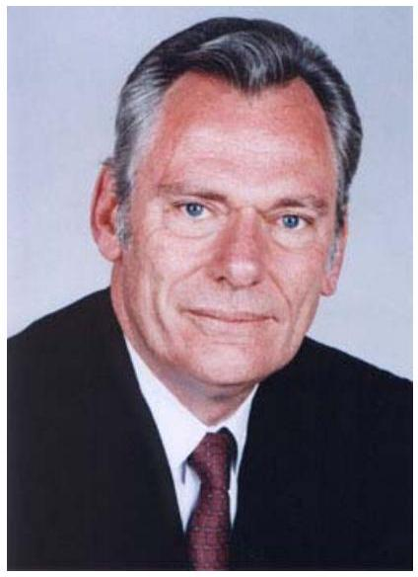
In 1966, Rollin King, a Texas businessman planning to launch an intrastate Texas airline, hired Herb Kelleher as outside counsel. (The business plan was drafted by the two men on a cocktail napkin in a local bar.) From the outset, the fledgling company was nearly shot down by legal challenges from rival carriers Texas International, Braniff, and Continental, which sought to persuade Texas courts that the state couldn't support another carrier. Kelleher, by then a partner in the venture, argued the case all the way to the U.S. Supreme Court and won. Since then, the company has always thought of itself as an underdog, its employees wearing that moniker as a badge of pride.
When Southwest finally received permission to operate in 1971, it had four Boeing aircraft and fewer than 70 employees, barely enough to operate. When it could not meet payroll, the company had to choose: sell one of its planes or lay off employees. It chose the former and asked its employees to cut turnaround time at the gate from 55 to 15 minutes. The tradition of Southwest employees, from pilots to ramp agents, pitching in to do what's necessary to help the company was born.
Herb Kelleher presented himself as an "aw shucks" kind-of down-home guy. The press ate up the stories of his midnight barbecues for night-shift workers and the humorous overlay he gave to everything the company did. But Kelleher was also one of the most talented strategists since Napolean and he was just as ruthless in implement his strategy.
The essence of Southwest was being an indirect low-cost competitor. Being indirect meant a route structure that did not overlay the majors. It meant flying LAX to Oakland rather than San Francisco, and Albuquerque to Baltimore rather than Washington DC. Being low cost meant not only competing with other airlines, but drawing customers out of their cars by specializing in short-haul routes.
The fixed costs of flying are large, so cutting costs on short routes is especially challenging. Kelleher kept gate turnaround times to 15 minutes. There were no assigned seats, no baggage forwarding to other airlines. There were no meals and flight attendants cleaned up the plane. Pilots worked longer hours than the majors and were paid less.
Over thirty years, no other airline was successful in replicating this amazingly effective focused strategy. JetBlue is now on the road to doing so. So was AirTran before SWA bought it.
Today (2011) Southwest is losing its focus as it tries to grow and grow. My standard trip from Albuquerque to Los Angeles is no longer point-to-point. And because the plane arrives in Albuquerque from Dallas, or, Tulsa, or other places, it is very often late. And, being late on a relatively short hop is the opposite of being low cost to many flyers.

